PETER Webex meeting 27. 8. 2020

WP3 – Management and CDE

- Project extension: proceedings started in PP
- The „ping-pong“ with PO will commence in September

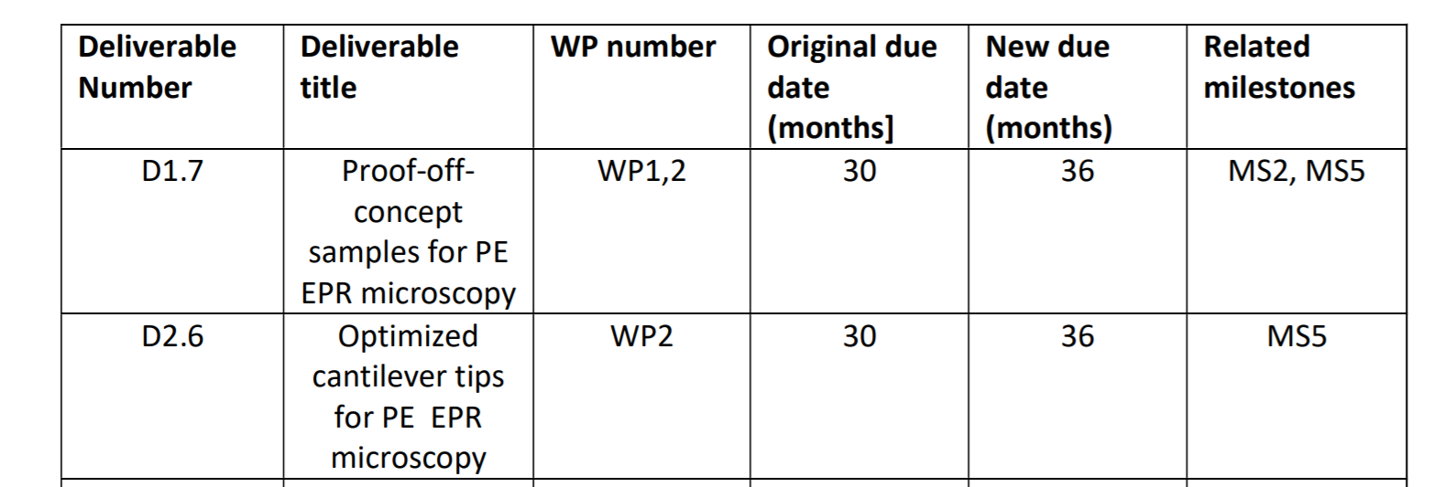
- „Overdue“ deliverables: What’s the status?

- Dissemination:
  - Outlook on publications? (so far 3)
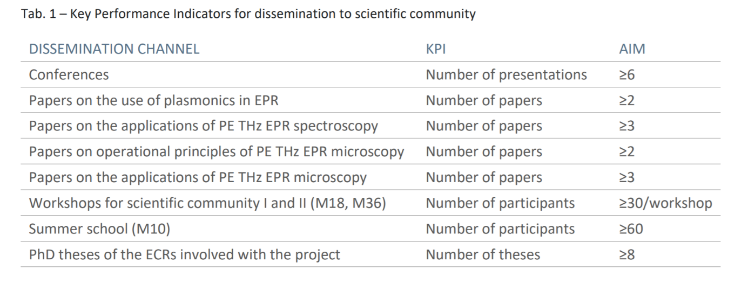
  - Plan from the proposal:
  - General public dissemination
    - Articles on journal blogs
    - Short videoclip – intro of PETER

  - Brochure to be handed out at workshops

  - Press release/Press conference at the end of the project

