PETER status meeting 29. 4. 2021

Tomáš Šikola, Alisa Leavesley, Božena Čechalová, Lorenzo Tesi, Monika Larruskain, Rainer Hillebrand, Joris van Slageren, Dominik Bloos, Elisaveta Nikulina, Jiří Liška, Martin Konečný, Zdeněk Nováček, Michal Pavera, Petr Neugebauer

Agenda
Publications
- Božena Čechalová reiterated the rules of publications under H2020 (Open Access)
- NGU publications will be reuploaded
- Open access will be bought for recent publications
Dissemination
- Lorenzo was on a RCS meeting disseminating to industry
- Božena on Research meets Business meeting by FETBRIEFING
- Tomáš Šikola - Invitation to MetaLight21 workshop in May 11 – 12 (PETER will be presented there by M. Hrtoň)

Update from USTUTT – Lorenzo TESI (see presentation)
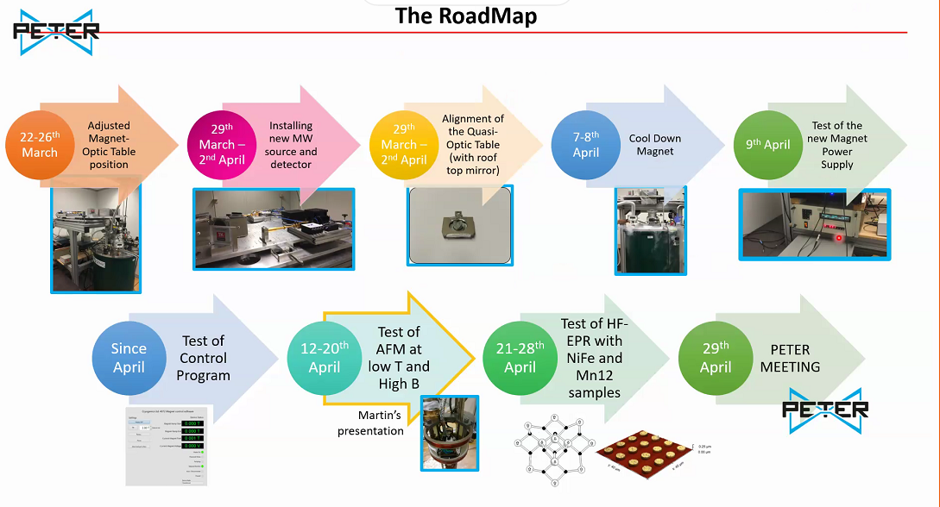

- Test carried out on a pellet of material – signal present but noisy
- Experiments planned with the single antenna
- Alisa is coming to USTUTT next week

Update on tip fabrication – Elisaveta (NGU) – see picture below
- 8 glass fiber tips
- Elisaveta polished the tips and deposited Ti/Au
- Discussion with Martin Hrtoň (simulations) – Martin should send presentation
- These tips are in Stuttgart ready for measurements

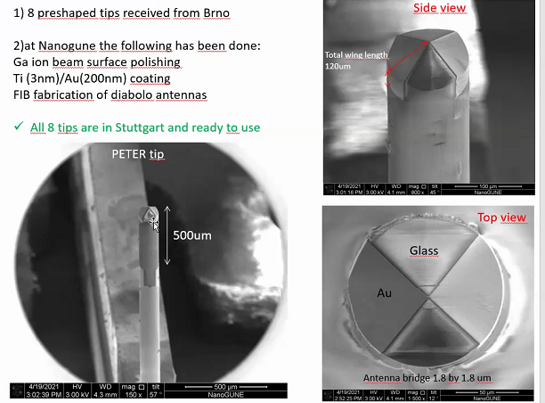

Update on AFM measurements – Martin Konečný (see presentation)
- Rotary pump from the He recovery line causing vibrations (around Christmas)
- Improved by adding a check valve, new pipe, and overall stabilisation of the system
- First scan measurement with the PETER probe (old, imperfect one, cca 200 nm Au layer on the tip)

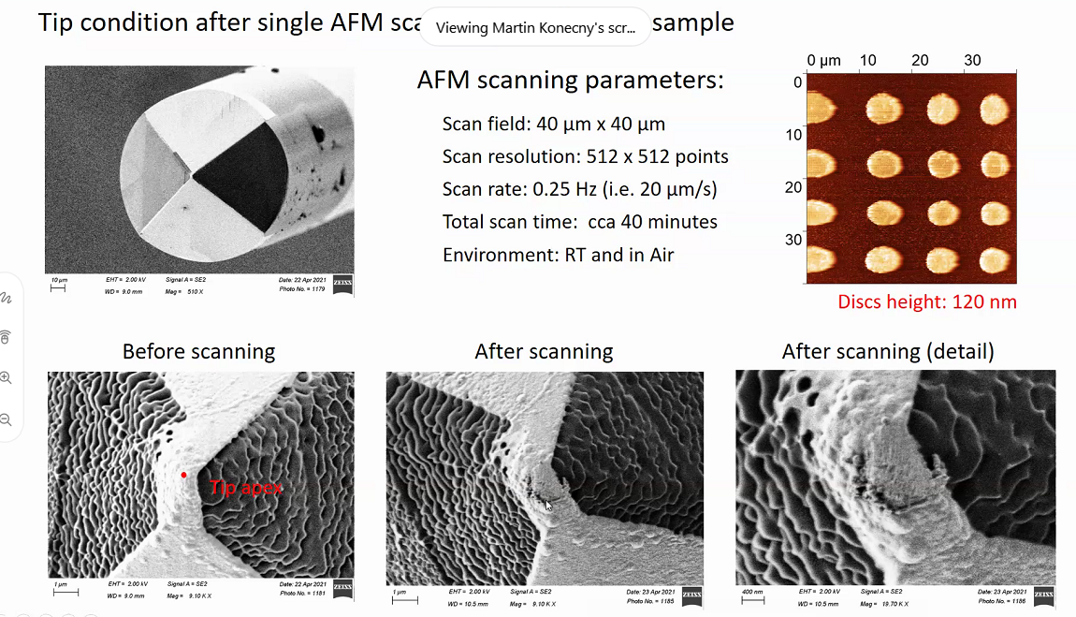

- RH: gold tip has generally bigger wear than Pt/Ir tips
- Quality of image comparable with commercial Akyiama probe

Update on probes fabrication – Brno
- TŠ: notified Elisaveta that there should be 5 tips from Brno incoming to NGU soon
- ZN: there should be about 20 probes by June

Update on samples – Jiří Liška (presentation)
- Peter Kepič worked on the permalloy disc samples (spin coating + EBL) – ready for shipment to USTUTT
- JL plans to fabricate Cu/phtalocyanine discs – optimisation in progress
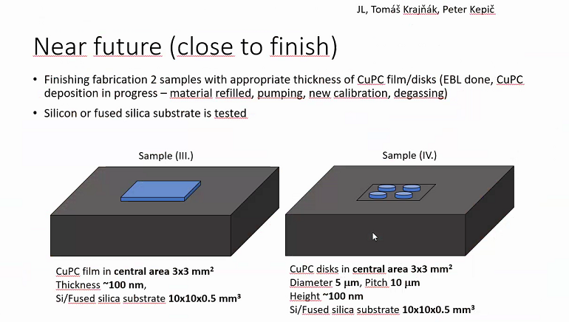

To do:
- Alisa plans to do checks and calibrations of signal modulations next week
- RH is available to dial in for remote consultation

- Martin Konečný will take a summer break but will resume his work in Stuttgart in August

- Next meeting: 21. May (Friday) at 14:00 (13:00 London time)

