PETER Status Meeting 10. 6. 2021

Božena Čechalová, Zdeněk Nováček, Lorenzo Tesi, Joris van Slageren, Rainer Hillenbrand, Alisa Leavesley, Tomáš Šikola, Dominik Bloos, Petr Neugebauer, Elizaveta Nikulina, Martin Hrtoň, Martin Konečný, Jiří Liška, Monika Larruskain
14:00 – 15:00 CET

Agenda:

BČ:
- Final Steering Meeting - 29. 6. (Tuesday) – 10AM (9AM UK time) – WEBEX (Božena will set up) – formal invitation will be sent to Remus (our new PO)
- Deliverables D3.8 (by Alisa and BČ) and D3.9 and 3.10 (now reviewed by TŠ) will be sent around for reviews shortly
- Video and a brochure for communication/dissemination will be done before end of June

LS: progress in USTUTT (see presentation)
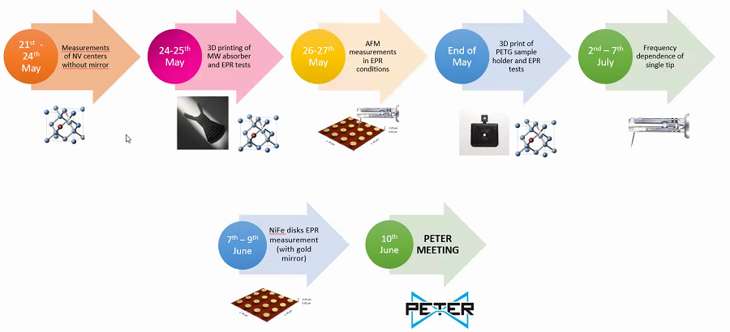
- No clear evidence that the tip is enhancing the signal
- demodulate the tip oscillation frequency
- measure at a fixed magnetic field as a function of tip distance
- increase the tip oscillation amplitude to get the 2nd (3rd) harmonics – record the signal at the primary frequency and higher harmonics simultaneously
AL: shipping parts from UK to Germany (like a modulation coil) is being a trouble due to high shippng costs – still figuring out how to go around it

MK: presentation on AFM scanning (the state of the tip afterwards) and the PETER probe test in cryostat at low T and high B (a drift when the field is changing).
ZN: two batches of probes have been sent to Elizaveta
EL: still working on them, the first batch was sent to USTUTT, the next 7 pieces will be sent by the end of June
- Also will prepare a report (manual) on how to polish the tips for the BUT guys to take over (deadline: beginning of July)

AL: not able to come to Germany (closed borders again)

To Do:
- Invite PO to Final meeting (BČ)
- Prepare the presentation (in case he accepts) – TŠ and all
- LS: finish the major revisions to the paper (accepted for publication)
- Prepare the D2.7. deliverable (J. v S.)

