Meeting Minutes – Final Steering Meeting
29. 6. 2021 - 10:00
Tomáš Šikola, Joris van Slageren, Lorenzo Tesi, Zdeněk Nováček, Martin Konečný, Rainer Hillenbrand, Petr Neugebauer, Božena Čechalová, Monika Goikoetxea Larruskain, Alisa Leavesley, Richard Wylde

Agenda:
- Technical report part B – draft is ready with information on 2019, needed to write parts for 2020 and 2021
- Deliverable 2.7 – final version (2 – from Alisa and TŠ) – Božena will compile and upload today
- Video – will be uploaded to web ASAP
- Meeting on 22 July 10:00 – to go over the Technical report
- Meeting on 30 August 10:00 – to go over presentations for Review meeting
- TK can buy the second amplifier for USTUTT for money refunded from EUROMAR – date on invoice must be June
- Monika was asked to send a scanned copy of the formal confirmation letter concerning the transfer of funds (with Yurdana) to Joris van Slageren

Scientific discussion:
- Tips – Zdeněk Nováček is finishing the „tip cookbook“
- Lorenzo Tesi – (i) EPR experiments at different sample position, (ii) first experiments with a tip (approaching/oscillating) – double demodulation scheme (see the presentation). Further experiments needed
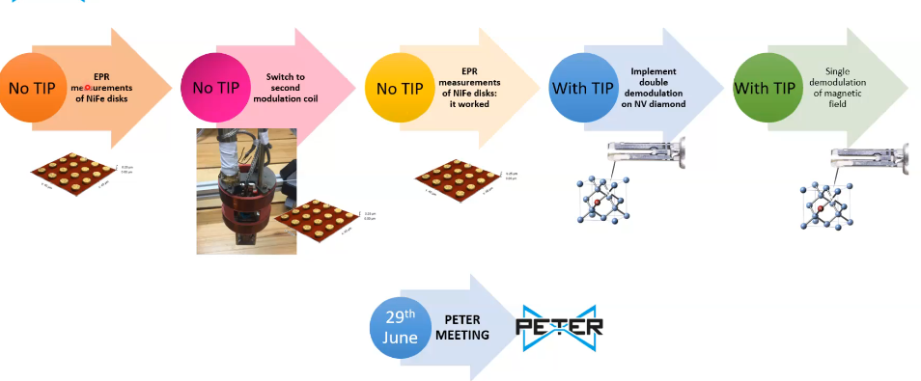

- Future work: in August, Martin is back in USTUTT
- EISMEA call (Transition challenge) – Alisa and Joris can have a chat about it (deadline September 22)
- Innovation radar questionnaire – reporting for the EC (will come around next week from BC)

